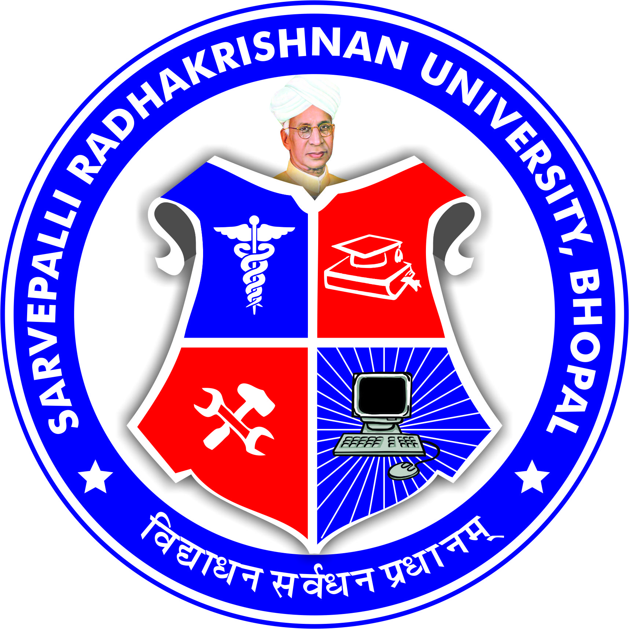
SARVEPALLI RADHAKRISHNAN UNIVERSITY
NH 12,RKDF IST CAMPUS, HOSHANGABAD ROAD, MISROD, BHOPAL (M.P.)
¼Statutory University established by Govt. of M.P. under section 2(F½ of UGC act)
Website: www.srku.edu.in, E-mail: info@srku.edu.in/srkubhopal@gmail.com
Phone: 0755-4700981 Fax: 07554700981

NO. DATE
SC&ST Grievance Committee Order
SC & ST Grievance committee of Sarvepalli Radhakrishnan University is here by reconstituted as below:
- Dr. Hemant Gadekar Chairman 8225000333
- Ms. Rupali Dehariya Member 7489266793
- Dr. Devendra Dhote Member 9826379534
- Mr. Ritesh Khatarkar Member 9039857769
- Dr. Supyar Singh Member 9755049849
- Ms. Laxmi Verma Secretary 6260929027
- Mr. Sumit Gigaulia Student Rep. 6263461729
(3rd Year Engg.)

- Mr. Durgesh Chandra Uikey Student Rep. 9301951971
(2nd Year Dip. Engg.)

Registrar

Note- Secretary of the committee shall be responsible for conducting meetings & maintaining minutes of meeting.

